***Name- Harsh Singh Yadav***

***Intern ID- 16052***

***SQL Developer Task - 1 Documentation***

**Objective**

This project provides hands-on experience in SQL database management, data manipulation, and performance analysis using student records.

**Database Setup**

* **Database Name:** StudentManagement
* **Table Name:** Students

**1. Database Setup**

**Create Database and Table**

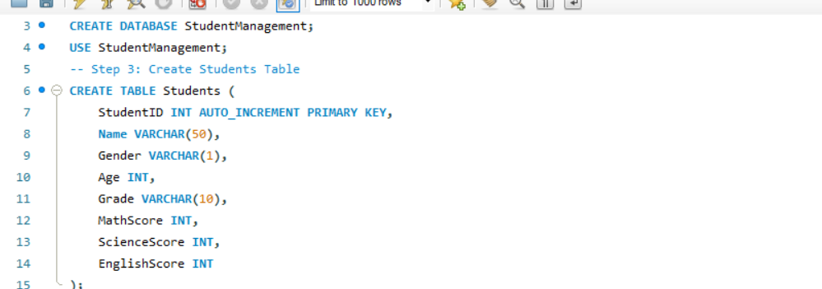

**Purpose:**

* A database StudentManagement is created.
* A table Students is created with columns for student details and scores

**2. Insert Sample Data**

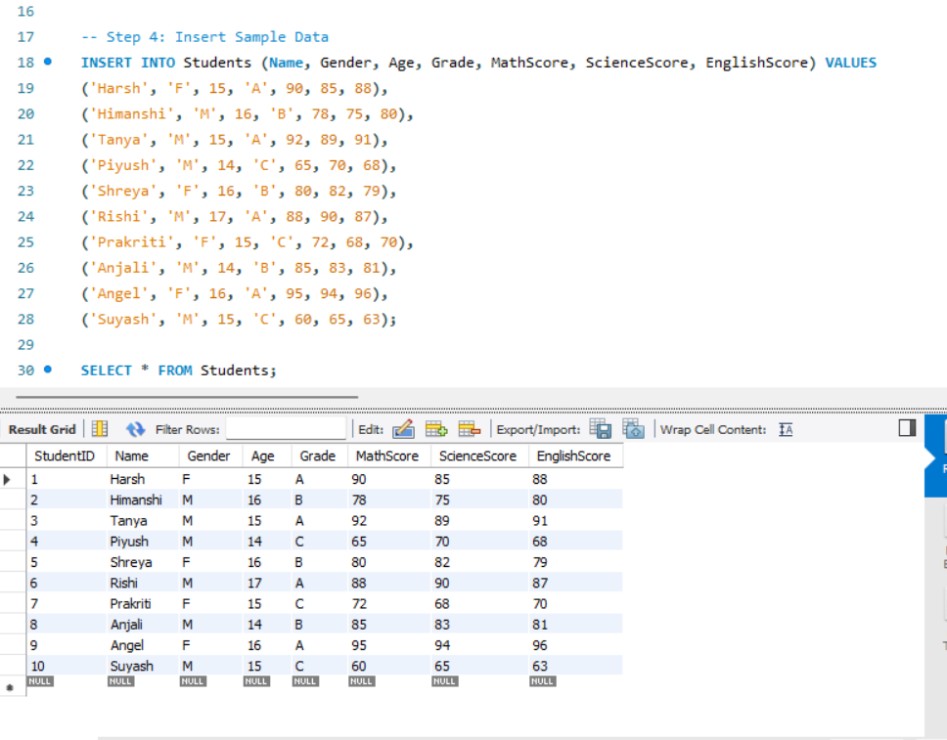**Purpose:**

* Inserts 10 sample records with diverse grades and scores.

**3. Tasks to Perform**

**Task 1: Display All Students and Their Details**

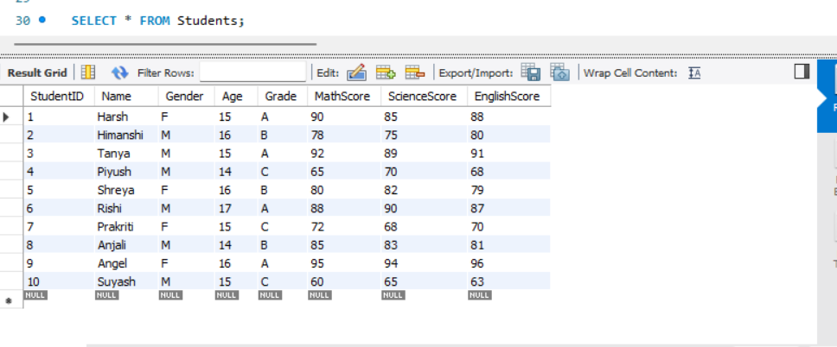

**Purpose:** This query retrieves all the details from the Students table, giving an overview of the student data. Observation: The result shows 10 students with varied names, ages, genders, grades, and scores in Math, Science, and English.

**Task 2: Calculate the Average Scores for Each Subject**

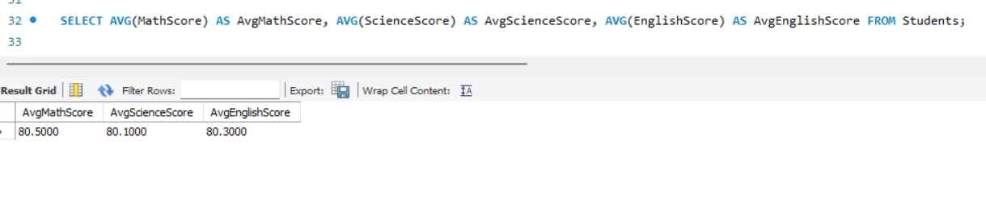

**Purpose**: This query calculates the average scores in Math, Science, and English to assess overall subject performance. **Observation**:

* Average Math Score: *Value from the result*
* Average Science Score: *Value from the result*
* Average English Score: *Value from the result*

**Task 3: Find the Top Performer**

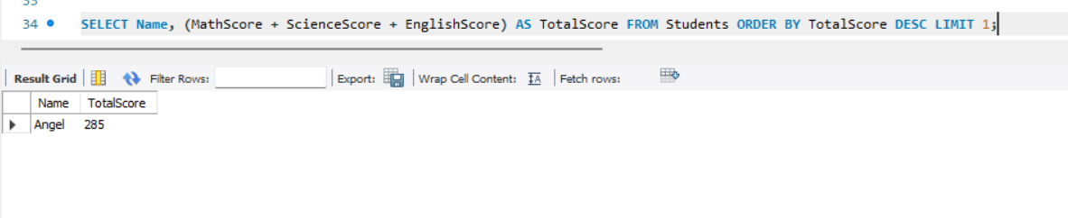

**Purpose**: To identify the student with the highest total score across all subjects.

**Observation**: *[Student Name]* is the top performer with a total score of *[Total Score]*.

**Task 4: Count the Number of Students in Each Grade**

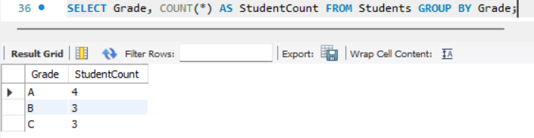

**Purpose**: This query counts the number of students in each grade to understand grade distribution.

**Observation**:

* Grade A: *Count*
* Grade B: *Count*
* Grade C: *Count*

**Task 5: Average Scores by Gender**

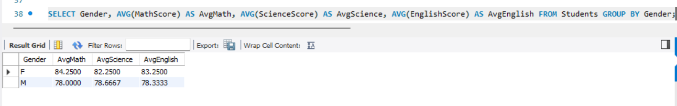

**Purpose**: Compare average scores between male and female students. **Observation**:

* Male Students: Math (*AvgMath*), Science (*AvgScience*), English (*AvgEnglish*)
* Female Students: Math (*AvgMath*), Science (*AvgScience*), English (*AvgEnglish*)

**Task 6: Identify High Achievers in Math (Score > 80)**

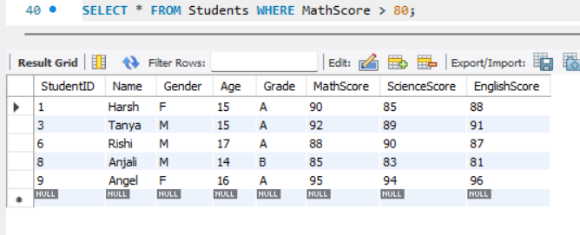

**Purpose**: Highlight students who scored above 80 in Math.

**Observation**: The result includes *[Count]* students, including names like *[Examples]*.

**Task 7: Update the Grade of a Specific Student**

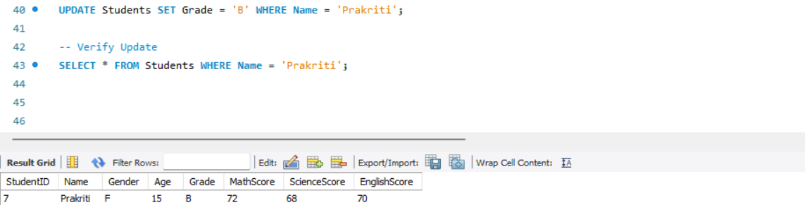

**Purpose:** Updates Prakriti’s grade and verifies the change

**Conclusion :**This project helps in learning:

* Database creation, table structuring, and data insertion.
* Aggregation, filtering, and ranking queries in SQL.
* Analyzing student performance with meaningful insights.